1. Install MySQL Workbench on your computer, connect to the local MySQL server, and take a screenshot of the default databases shown in the Schemas panel.

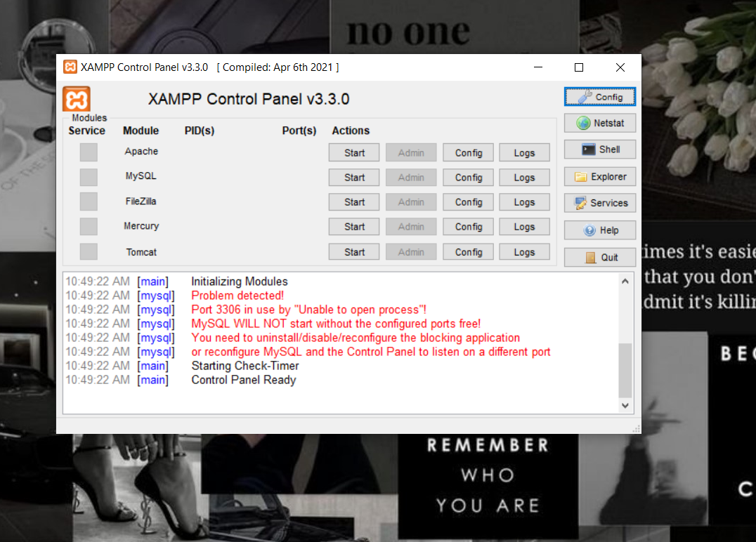

2. Create a new database called InstaClone in MySQL Workbench, then create a table named Users with columns: user_id (INT, primary key), username (VARCHAR), email (VARCHAR), and followers_count (INT).

CREATE DATABASE InstaClone;

USE InstaClone;

CREATE TABLE Users (
user_id INT PRIMARY KEY,
username VARCHAR(100),
email VARCHAR(40),
followers_count INT
);

3.Insert 3 sample users into the Users table you created, using realistic Instagram-style usernames and follower counts.

INSERT INTO Users (username, follower_count)
VALUES
('r.khushiee, 267),
('ishi__1801', 482),
('_.fenny', 675);

4. Create another table in the InstaClone database called Posts with columns: post_id (INT, primary key), user_id (INT), caption (VARCHAR), and post_date (DATE). Add a foreign key from Posts.user_id to Users.user_id to establish a relationship.
USE InstaClone;

CREATE TABLE Posts (
post_id INT AUTO_INCREMENT PRIMARY KEY,
user_id INT,
caption VARCHAR(90),
post_date DATE,
FOREIGN KEY (user_id) REFERENCES Users(user_id)
);

5. Write a short comparison (3-4 lines each) of MySQL, PostgreSQL, Oracle, and SQLite, focusing on where each one is commonly used (for example: web apps, mobile apps, enterprise systems, etc.).

MySQL
MySQL is widely used for web applications and online services.
It is popular with PHP, WordPress, and other web-development stacks.
It works well for applications that need a reliable, scalable relational database.

PostgreSQL
PostgreSQL is commonly used in web apps, data-intensive applications, and analytics.
It supports advanced SQL features, complex queries, and extensible data types.
It is often chosen for systems where flexibility and data integrity are important.

Oracle
Oracle Database is primarily used in large enterprise systems.
It is common in banking, telecommunications, government, and large organizations.
It provides extensive features for high availability, security, and large-scale data management.

SQLite
SQLite is commonly used in mobile apps, desktop software, and embedded systems.
It stores the entire database in a single local file and requires no separate server.
It is well suited for lightweight applications and local/offline data storage.

